Final Paper

Subject: Advanced Distributed Systems

Design of a Hierarchical Consistency Model
and Conflict Resolution Mechanism
in Multi-Agent Shared Memory Systems

YU BAOQI

Advisor: Baek Geon-hyo

June 2026

Major of Computer Science and Technology
Graduate School of Youngsan University

목 차
LIST OF TABLES iii
LIST OF FIGURES iv
Chapter 1 Introduction 1
1.1 Research Background 1
1.2 Research Motivation and Problem Statement 1
1.3 Research Objectives and Contributions 2
1.4 Research Questions 2
1.5 Organization of the Thesis 3
Chapter 2 Related Work 4
2.1 Multi-Agent Memory Structure and Shared Memory Research 4
2.2 Distributed System Consistency Models and Version Management Research 5
2.3 Conflict Detection, Mediation Strategies, and Semantic Adjustment Research 6
2.4 Overall Research Trend Synthesis 6
2.5 Common Limitations of Existing Research 7
2.6 Differentiation of This Study 7
Chapter 3 System Model and Design 9
3.1 System Assumptions and Scope 9
3.2 Multi-Agent Shared Memory Formal Model 9
3.3 Formal Definitions of Three Conflict Types 10
3.4 Hierarchical Consistency Model Design 10
3.5 Conflict Resolution Mechanism Design 11
Chapter 4 Implementation and Experiment Design 12
4.1 Prototype Implementation Environment 12
4.2 Overall System Architecture 13
4.3 Experiment Design 14
4.4 Comparison Group Configuration 14
4.5 Evaluation Metrics 15
4.6 Experimental Procedure 15
Chapter 5 Results and Analysis 17
5.1 Experimental Results Overview 17
5.2 Comprehensive Performance Results by Comparison Group 17
5.3 Accuracy Analysis by Scenario 19
5.4 Ablation Study Analysis 20
5.5 Latency Analysis 22
5.6 Result Interpretation and Discussion 23
Chapter 6 Conclusion and Implications 26
6.1 Research Summary 26
6.2 Research Implications 27
6.2.1 Academic Implications 27
6.2.2 Practical Implications 28
6.3 Limitations of the Study 29
6.4 Future Research Directions 30
References 31
국문 초록 32
ABSTRACT 34
APPENDIX 36

LIST OF TABLES
Table 1. Comprehensive Performance Results by Comparison Group 17
Table 2. Accuracy and LLM Call Count Comparison by Scenario 19
Table 3. Ablation Study Δ Analysis Results 20
Table 4. Detailed Latency Analysis by Scenario 22

LIST OF FIGURES
Figure 1. Comprehensive Accuracy and Average Latency Comparison by Group 18
Figure 2. Accuracy Comparison by Scenario and Group 20
Figure 3. Performance Changes Before and After Ablation Study 21
Figure 4. Latency Distribution by Group (Box Plot, N=90) 23

Chapter 1 Introduction

1.1 Research Background
Recently, large language model (LLM)-based agent systems have been rapidly expanding from single-agent-centric structures to multi-agent architectures where multiple agents share roles and collaborate. This change demonstrates high applicability in that it enables complex tasks to be processed by separating them into planning, execution, and review stages, but at the same time greatly highlights the importance of memory systems that can stably share state and knowledge among agents. In particular, in order for multiple agents to maintain the same task context, reuse intermediate results, and accumulate the basis for decision-making, the structure and operation of shared memory must be systematically designed and managed.

1.2 Research Motivation and Problem Statement
However, in multi-agent shared memory environments, various conflicts can arise in the process of multiple agents simultaneously accessing and updating the same memory entries. Representative examples include visibility conflicts where certain information is visible only to some agents or is propagated late, ordering conflicts where outdated records are belatedly reflected instead of the latest version, and semantic conflicts where different agents record semantically contradictory conclusions on the same topic. If these conflicts are not properly managed, inconsistencies in memory state accumulate, leading to decreased task success rates and significantly undermining the reliability of final results.

Existing research has conceptually described multi-agent memory from the perspectives of shared memory and distributed memory, or has proposed adaptive memory management methods utilizing role-based agents. However, many prior studies have not sufficiently addressed formal definitions of conflict types, implementable consistency protocols, systematic comparisons of multiple conflict resolution strategies, and handling of conflicts occurring at the level of linguistic semantics. Meanwhile, models proposed in the distributed systems field, such as strong consistency, eventual consistency, and causal consistency, provide important theoretical foundations, but applying them directly to LLM-based multi-agent memory environments requires additional design considerations that account for the characteristics of agent collaboration.

1.3 Research Objectives and Contributions
Accordingly, this study aims to design a hierarchical consistency model that applies strong consistency to working memory and eventual consistency to long-term memory for multi-agent shared memory systems. It also proposes an integrated conflict resolution mechanism combining timestamp-priority, trust-score-priority, leader-agent-mediation strategies with an LLM-based Judge Agent for semantic conflict detection and adjustment. To this end, a Python-based prototype and SQLite shared memory storage are implemented, and experiments are conducted in an environment where three role-agents—Planner, Executor, and Reviewer—participate to systematically verify the conflict resolution capabilities.

1.4 Research Questions
RQ1. Can visibility, ordering, and semantic conflicts occurring in multi-agent shared memory environments be resolved more accurately by the proposed method compared to existing methods?
RQ2. Does the hierarchical consistency model applying different consistency levels to working memory and long-term memory improve the balance between accuracy and latency compared to a single consistency model?
RQ3. Among timestamp-priority, trust-score-priority, leader-agent-mediation, and Judge Agent-based semantic judgment strategies, which is most effective for each conflict type?
RQ4. Can the LLM-based Judge Agent effectively detect and adjust semantic conflicts that are difficult to detect through structural version management methods?
RQ5. Can the individual contributions of the structural conflict resolution module and the Judge Agent module be separately confirmed through an ablation study?

1.5 Organization of the Thesis
This thesis is organized as follows. Chapter 2 reviews prior research on multi-agent memory structures, distributed system consistency models, and conflict resolution strategies, and presents the differentiation of this study. Chapter 3 describes in detail the system model, formal definitions of conflict types, and the design of the hierarchical consistency model and conflict resolution mechanism. Chapter 4 explains the prototype implementation, experimental design, comparison group configuration, and evaluation methods. Chapter 5 presents experimental results for eight comparison groups and conducts comprehensive interpretation including ablation studies and latency analysis. Finally, Chapter 6 concludes with the academic and practical implications of the research, limitations, and future research directions.

Chapter 2 Related Work
This chapter reviews prior research related to this study and presents the differentiation of this study based on the limitations of existing research.
As LLM-based systems expand beyond single-agent-centric structures to forms where multiple agents share roles and collaborate, the importance of memory structures supporting information sharing and state synchronization among agents has greatly increased. In particular, in multi-agent environments, information such as task plans, execution results, intermediate reasoning grounds, and evaluation feedback is repeatedly read and updated by multiple agents, so the structure and operation method of shared memory determine the reliability and performance of the entire system. Against this background, existing prior research has generally developed in three main areas: multi-agent memory structure research, distributed system consistency model research, and conflict detection and resolution strategy research.

2.1 Multi-Agent Memory Structure and Shared Memory Research
First, multi-agent memory structure research has developed centered on memory storage forms, access methods, and hierarchical structures to support inter-agent collaboration. Existing research has distinguished multi-agent memory from the perspectives of shared memory and distributed memory, and has proposed structures that can enhance collaboration efficiency by utilizing common states. Additionally, some research has demonstrated the scalability of agent collaboration by proposing hierarchical structures that distinguish working memory, long-term memory, and external tool memory, or adaptive mechanisms where role-based agents retrieve and update memory as needed.
However, a significant portion of such research has focused on explaining the conceptual usefulness of memory structures and has not reached the level of formally defining and verifying concurrent access, record order reversal, version conflicts, and information visibility problems that occur in actual multi-agent environments. In particular, read/write rules and conflict management policies for shared memory have often not been specifically designed, resulting in relatively insufficient discussion on how to maintain system consistency at the actual implementation stage. Therefore, while existing memory structure research is significant in presenting architectural directions for collaboration, there is a gap in providing implementable consistency protocols and conflict resolution strategies.

2.2 Distributed System Consistency Models and Version Management Research
Second, distributed system consistency model research has provided theoretical foundations for ensuring data integrity in environments where multiple nodes maintain shared state. Strong consistency (Linearizability) [3] provides high accuracy by guaranteeing that all operations appear to follow a single global order, but may incur concurrency control costs and increased latency. In contrast, eventual consistency [4] prioritizes availability and scalability over immediate consistency and is designed to converge to the same state over time. Causal consistency [5] maintains the causal order between operations while allowing concurrent processing, offering a middle ground.
However, existing distributed system consistency models have primarily developed under the premise of key-value data or transaction-centric structural integrity, making it difficult to apply them directly to LLM-based multi-agent memory environments that include natural language text and reasoning results. For example, working memory and long-term memory differ in access frequency, allowable latency range, and update purposes, so uniformly applying the same consistency level makes it difficult to secure the balance between accuracy and performance. Additionally, since text-based memory can be semantically contradictory even if the content stored under the same key does not structurally conflict, a semantic-level conflict detection mechanism is additionally required.

2.3 Conflict Detection, Mediation Strategies, and Semantic Adjustment Research
Third, conflict detection and adjustment research deals with strategies for detecting and resolving conflicts that arise when multiple entities update the same data or memory entries. In existing research and practical systems, timestamp-priority methods, latest-version-priority methods, leader or central coordinator-based mediation methods, and trust-score or priority-based selection methods have generally been utilized. These approaches have the advantage of being able to handle structural problems such as simultaneous write conflicts or ordering conflicts with relatively simple rules. Recently, approaches utilizing LLMs to determine whether two conflicting text records contain semantic contradictions have also been explored.
However, existing conflict resolution research has generally focused on the detection and resolution of structural conflicts, and has often failed to systematically address semantic conflicts such as contradictory conclusions on the same topic or contextual inconsistencies. Additionally, research that compares various strategies such as timestamp-priority, trust-score-priority, and leader mediation under the same experimental conditions and evaluates both accuracy and latency together has been relatively limited. LLM-based semantic judgment approaches have also shown potential, but research integrating them with structural conflict handling in actual multi-agent shared memory systems is still insufficient.

2.4 Overall Research Trend Synthesis
Synthesizing the above prior research, related research can be summarized as having developed in three main directions. First, as the design of memory structures and retrieval mechanisms supporting multi-agent collaboration has been actively discussed, the necessity of shared memory and the possibility of hierarchical design have been presented. Second, traditional consistency theories and version management techniques in distributed systems have functioned as a key foundation explaining shared state integrity, providing principles applicable to multi-agent memory. Third, conflict detection and mediation strategy research has accumulated various rule-based approaches [9] for resolving structural conflicts, and recently LLM-based semantic judgment methods have been explored.

2.5 Common Limitations of Existing Research
The common limitations of existing research can be summarized as follows. First, many studies have conceptually presented the structure and applicability of multi-agent memory but have not sufficiently presented implementation-level protocols including shared memory access rules, version management methods, and formal definitions of conflict types. Second, while traditional consistency models in distributed systems provide important theoretical foundations, they have not simultaneously reflected factors such as the characteristic differences between working memory and long-term memory, the possibility of semantic contradictions in natural language-based memory, and differences in agent roles. Third, existing conflict resolution research has mainly focused on structural conflicts, and systematic approaches to semantic conflicts have been insufficient.

2.6 Differentiation of This Study
Therefore, this study proposes a hierarchical consistency model that distinguishes between working memory and long-term memory in multi-agent shared memory systems and applies appropriate consistency levels to each. Specifically, strong consistency is applied to working memory to prioritize the integrity of the current task context, while eventual consistency is applied to long-term memory to ensure scalability and flexibility. Additionally, this study formally defines three types of conflicts—visibility conflicts, ordering conflicts, and semantic conflicts—and proposes an integrated conflict resolution mechanism including timestamp-priority, trust-score-priority, leader-agent mediation, and LLM-based Judge Agent.

Chapter 3 System Model and Design
Based on the above review of prior research, this chapter describes in detail the formal model of the multi-agent shared memory system, definitions of conflict types, and the design of the hierarchical consistency model and conflict resolution mechanism.

3.1 System Assumptions and Scope
This study adopts the Design Science Research methodology to design and experimentally evaluate a hierarchical consistency model and conflict resolution mechanism as an artifact for multi-agent shared memory systems. The system is designed under the following assumptions.
• The number of agents is fixed at 3 (Planner, Executor, Reviewer), and each agent performs a specific role.
• Shared memory operates in a SQLite-based single-machine environment, and all agents can access the same memory storage.
• The network is stable, and message loss or node failures are assumed not to occur.
• Memory consists of two layers: Working Memory and Long-term Memory.

3.2 Multi-Agent Shared Memory Formal Model
The shared memory system is defined as a set of memory entries. Each memory entry consists of a key, value, version number, timestamp, and agent identifier (agent_id). Memory entries are uniquely identified by the key, and the version number increments by 1 with each update operation. A read operation specifies the key and memory type to return the currently stored value, and a write operation specifies the key, value, and agent identifier to create a new memory entry or update an existing entry.
The formal definition of a memory entry is as follows: MemoryEntry = ⟨key, value, version, timestamp, agent_id, memory_type⟩. Here, version ∈ ℕ represents the update count, timestamp ∈ ℝ⁺ represents Unix time, and memory_type ∈ {WORKING, LONG_TERM} represents the memory layer.

3.3 Formal Definitions of Three Conflict Types
This study formally defines conflicts occurring in multi-agent shared memory environments into the following three types.
Visibility Conflict: Occurs when Agent B reads key k after Agent A has performed a write on memory key k, but A's update is not reflected in the state read by B. This means the agent is in a state of reading a stale version and is detected by the condition agent.last_seen_version[k] < current_version[k].
Ordering Conflict: Occurs when Agent B performs a write based on a past version, overwriting the latest value that Agent A had already updated. This is detected under the condition 0 < agent.last_seen_version[k] < current_version[k] and is a special case where a visibility conflict leads to a write operation.
Semantic Conflict: Occurs when two agents have performed structurally normal writes to the same key, but the recorded content is semantically contradictory or contains mutually exclusive conclusions. This cannot be detected through version comparison alone and is a conflict type requiring natural language semantic analysis. For example, this applies when Agent A records 'the system is ready for operational deployment' and Agent B records 'the system has critical bugs and cannot be deployed' on the same key.

3.4 Hierarchical Consistency Model Design
This study designs a hierarchical consistency model that applies different consistency levels to working memory and long-term memory. The rationale for this hierarchical approach is that the access characteristics and consistency requirements of the two memory layers are fundamentally different.
Working Memory — Strong Consistency: Working memory stores real-time collaboration information such as the current task plan (task_plan), task status (task_status), and current step (current_step). Since access frequency is high and the risk of cascading errors due to incorrect information is significant, this study applies lock-based strong consistency to working memory. Under strong consistency, all read/write operations are serialized, and agents can always read the latest value.
Long-term Memory — Eventual Consistency: Long-term memory stores accumulated information such as the knowledge base (knowledge_base), decision log (decision_log), and feedback history (feedback_history). Since the update frequency is relatively low and some delay is tolerable, this study applies eventual consistency to long-term memory. Under eventual consistency, write operations are performed in a non-blocking manner, and convergence occurs through a last-write-wins policy when conflicts arise.
The hierarchical consistency model is implemented by the HierarchicalConsistency class, which delegates read/write operations to StrongConsistency or EventualConsistency depending on the memory type. It also provides an upgrade_to_long_term mechanism for promoting verified working memory entries to long-term memory.

3.5 Conflict Resolution Mechanism Design
This study designs a three-stage conflict resolution mechanism that integrally handles structural and semantic conflicts.
Stage 1: Conflict Detection. The ConflictDetector compares the agent's state (AgentState) with the current version in the memory store to detect visibility and ordering conflicts. Visibility conflicts are detected when last_seen_version < current_version, and ordering conflicts are detected when 0 < last_seen_version < current_version.
Stage 2: Structural Pre-filtering. For detected conflicts, one of three structural resolution strategies—timestamp-priority, trust-score-priority, or leader-agent mediation—is applied. The timestamp-priority strategy selects the most recently recorded value, the trust-score-priority strategy selects the value from the agent with a higher Trust Score (success count/total attempt count), and the leader-agent mediation strategy selects the value based on rule-based judgment by the Reviewer agent.
Stage 3: Judge Agent Semantic Judgment. For conflicts unresolved by structural filtering, particularly semantic conflicts between natural language texts, the LLM-based Judge Agent intervenes. The Judge Agent calls the DeepSeek-chat [10] API to determine whether the two values contain semantic contradictions and selects the more appropriate value when a conflict exists. The Judge Agent's prompt includes the memory key, agent information, and two conflicting values, and returns the judgment in JSON format including conflict status (conflict), resolution direction (resolution), and selected value (selected_value).
This three-stage mechanism is integrally operated by the ConflictResolver, and the activation of each component can be adjusted through ResolverConfig. When pre-filtering is applied, the Judge Agent is selectively called only for values requiring natural language-level semantic judgment, minimizing unnecessary LLM API calls.

Chapter 4 Implementation and Experiment Design
This chapter describes the prototype implementation and experimental design of the system designed in Chapter 3.

4.1 Prototype Implementation Environment
The prototype was implemented based on Python 3.12, and the main components are as follows. SQLite was used as the shared memory storage, with WAL (Write-Ahead Logging) [12] mode enabled to secure concurrent read/write performance. The DeepSeek-chat [10] model was used for LLM API calls, accessing DeepSeek's OpenAI-compatible endpoint through the OpenAI SDK [11]. NumPy was utilized for experimental data collection and statistical analysis.
The complete source code and experimental data of the prototype are publicly available in the GitHub repository (https://github.com/ybq9430/multi-agent-shared-memory-experiment), and can be reproduced by setting the API key as an environment variable in config.py.

4.2 Overall System Architecture
The system consists of 6 core modules:
• agents — BaseAgent (read/write/trust score tracking), PlannerAgent, ExecutorAgent, ReviewerAgent, JudgeAgent (LLM-based semantic judgment)
• memory — SharedMemoryStore (SQLite-based version-managed storage), MemoryEntry, ConflictRecord, AgentState data models
• conflict — ConflictDetector (structural conflict detection), ConflictResolver (3-stage resolution pipeline integration)
• consistency — StrongConsistency (lock-based), EventualConsistency (non-blocking), HierarchicalConsistency (hierarchical integration)
• strategies — timestamp-priority (resolve_timestamp), trust-score-priority (resolve_trust_score), leader mediation (resolve_leader)
• experiments — ExperimentRunner (execution loop), ScenarioGenerator (3 scenario types), build_groups (8 comparison groups), MetricsCollector, result output and CSV export
The data flow proceeds in the order: ScenarioGenerator → Agent writes → ConflictDetector → ConflictResolver (including Judge Agent) → MetricsCollector → Reporter.

4.3 Experiment Design
The purpose of the experiment is to verify what advantages and limitations the proposed hierarchical consistency model and conflict resolution mechanism have compared to existing methods in multi-agent shared memory environments. This experiment was conducted according to the experimental plan established in week 10.
The experimental environment was configured as follows: Python 3.12, DeepSeek-chat [10] API, SQLite (WAL mode), with 3 agents (Planner, Executor, Reviewer) participating in a Windows 11 environment. The experiment was conducted with 8 comparison groups, each repeating 3 conflict scenarios 30 times, for a total of 720 executions. The random seed was fixed at 42 to ensure identical workload distribution across comparison groups.

4.4 Comparison Group Configuration
The comparison groups were configured as 8 groups to confirm performance differences between existing and proposed methods while also verifying the individual contributions of key modules through ablation studies.
Group 1 (Baseline): No conflict detection, no strategy, no Judge Agent. Last-write-wins only.
Group 2 (StrongOnly): Conflict detection applied, strong consistency only, no strategy or Judge Agent.
Group 3 (TimestampPriority): Conflict detection + timestamp-priority strategy + pre-filtering.
Group 4 (TrustScorePriority): Conflict detection + trust-score-priority strategy + pre-filtering.
Group 5 (LeaderMediation): Conflict detection + leader-agent mediation + pre-filtering.
Group 6 (Ablation1_NoJudge): Hierarchical consistency + all structural strategies + pre-filtering, Judge Agent excluded.
Group 7 (Ablation2_NoPreFilter): Hierarchical consistency + all structural strategies + Judge Agent included, pre-filtering excluded.
Group 8 (FullProposed): Hierarchical consistency + all structural strategies + Judge Agent + pre-filtering. Proposed method.

4.5 Evaluation Metrics
The evaluation metrics for the experiment were set as the following four:
• Conflict Resolution Accuracy: The percentage (%) of total repetitions where the resolved value matches the ground truth.
• Memory Consistency Maintenance Rate: The percentage (%) of total repetitions where conflicts were actively resolved. The percentage not left unattended by last-write-wins.
• Task Final Success Rate: The percentage (%) where the resolved value exists as a valid value.
• Average Conflict Resolution Latency: The average time (ms) from conflict detection to resolution.

4.6 Experimental Procedure
The experiment was conducted through the following procedure.
1. Prototype initialization: Initialize SQLite shared memory tables, agent information, version numbers, and timestamp fields.
2. Workload generation: Generate input data corresponding to simultaneous write conflicts, version order conflicts, and semantic conflicts through ScenarioGenerator.
3. Execution by comparison group: Execute 3 scenarios × 30 repetitions under identical conditions for each of the 8 comparison groups.
4. Conflict detection recording: Record conflict occurrence, conflict type, related memory key, and agent ID for each execution.
5. Conflict resolution: Determine the final memory value according to each comparison group's policy and store the resolution result.
6. Judge Agent evaluation: For semantic conflict scenarios, compare the LLM-based Judge Agent's judgment result with the ground truth label.
7. Ablation study analysis: Compare the Judge Agent removal condition (Ablation1) and structural pre-filtering removal condition (Ablation2) with the proposed method (FullProposed) to calculate per-module Δaccuracy, Δlatency, and LLM call count.
8. Evaluation metric calculation: Calculate conflict resolution accuracy, memory consistency maintenance rate, task success rate, and average latency.
This study complied with personal information protection and research ethics standards during data collection and utilization. The experimental data is synthetic data generated in a simulation environment and does not contain actual user information, and the data processing procedures were reviewed according to the research ethics checklist.

Chapter 5 Results and Analysis
This chapter presents the experimental results of the 8 comparison groups conducted according to the experimental design in Chapter 4 and interprets them in connection with the research hypotheses.

5.1 Experimental Results Overview
In this study, to verify the effectiveness of the proposed hierarchical consistency model and conflict resolution mechanism in multi-agent shared memory systems, a Python-based prototype and SQLite shared memory storage were implemented, and 720 experiments were conducted in an environment where 3 agents (Planner, Executor, Reviewer) participated, with 8 comparison groups each repeating 3 conflict scenarios 30 times. The proposed method (FullProposed) recorded an average accuracy of 93.3% across all scenarios, a 22.2%p improvement over the Baseline (71.1%).

5.2 Comprehensive Performance Results by Comparison Group
Table 1 presents a comprehensive summary of accuracy, memory consistency maintenance rate, and average latency for the 8 comparison groups across three scenarios. All groups that applied conflict detection and resolution mechanisms achieved 100% consistency maintenance rate, while Baseline and StrongOnly remained at 0%. In terms of comprehensive accuracy, the proposed method (FullProposed) was highest at 93.3%, a 22.2%p improvement over the Baseline (71.1%).

Table 1. Comprehensive Performance Results by Comparison Group
Group | Accuracy (%) | Consistency (%) | Success (%) | Avg Latency (ms)
1_Baseline | 71.11 | 0.00 | 100.00 | 4.38
2_StrongOnly | 71.11 | 0.00 | 100.00 | 4.92
3_TimestampPriority | 91.11 | 100.00 | 100.00 | 4.35
4_TrustScorePriority | 62.22 | 100.00 | 100.00 | 5.47
5_LeaderMediation | 62.22 | 100.00 | 100.00 | 5.31
6_Ablation1_NoJudge | 91.11 | 100.00 | 100.00 | 5.45
7_Ablation2_NoPreFilter | 75.56 | 100.00 | 100.00 | 1485.75
8_FullProposed | 93.33 | 100.00 | 100.00 | 478.72

As can be confirmed in Table 1, Baseline and StrongOnly, which did not apply the conflict detector, recorded 0% consistency maintenance rate because they could not detect or resolve conflicts even when they occurred, while all comparison groups that applied the conflict detector (Groups 3–8) achieved 100% consistency maintenance rate. This suggests that regardless of the type of conflict resolution strategy, the conflict detection module itself is a necessary condition for ensuring memory consistency.
Meanwhile, Ablation2 (NoPreFilter), which did not include the Judge Agent, recorded a comprehensive accuracy of 75.56%, demonstrating that structural strategies alone cannot adequately resolve semantic conflicts, resulting in decreased overall performance. This is because without pre-filtering, the Judge Agent attempted to handle structural conflicts as well, leading to misjudgments and a decrease in simultaneous write accuracy to 46.67%.

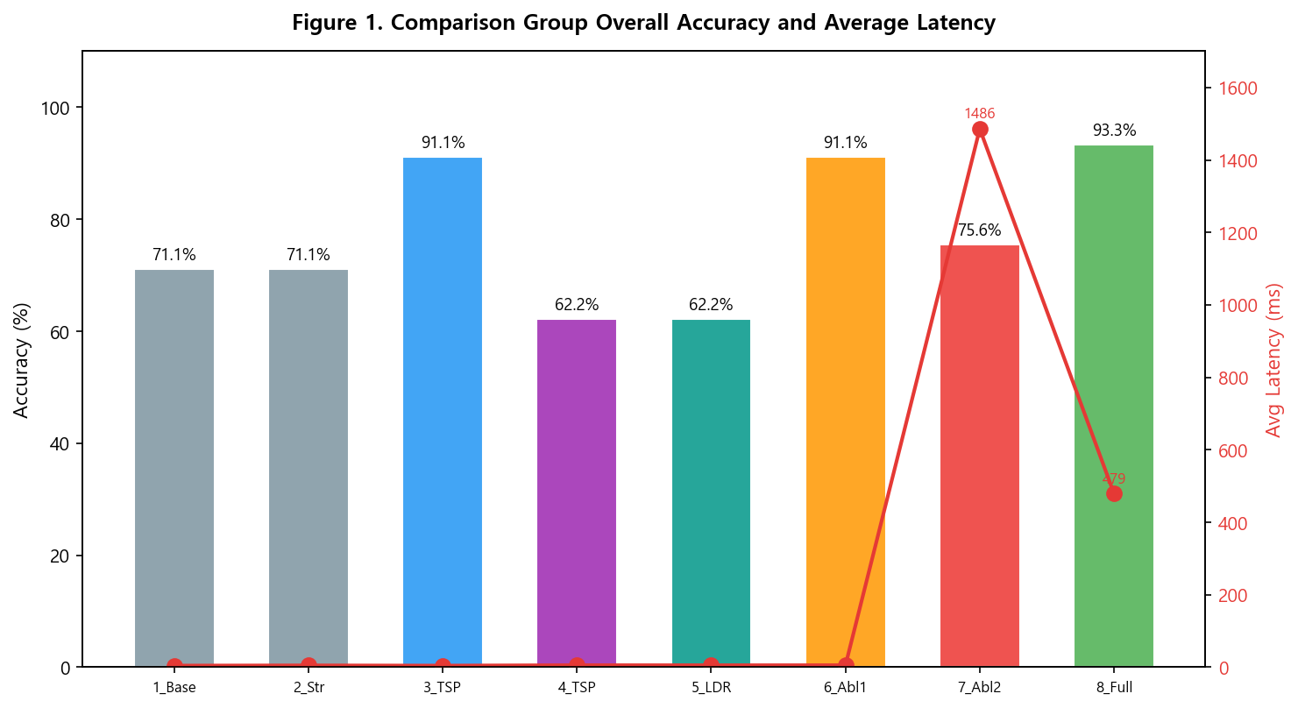
Figure 1. Comprehensive Accuracy and Average Latency Comparison by Group

Figure 1 is a dual-axis graph showing the comprehensive accuracy (bars) and average latency (line) of the 8 comparison groups. FullProposed achieved the highest comprehensive accuracy of 93.3% while recording an average latency of 478.7ms, which is 3.1 times lower than Ablation2 (1485.8ms). Groups 1–6 all showed low latency within 10ms, and groups applying structural strategies demonstrated practical value by simultaneously achieving high accuracy and low latency.

5.3 Accuracy Analysis by Scenario
Table 2 shows the accuracy and LLM call count for each comparison group by scenario. In the simultaneous write conflict scenario, TimestampPriority, Ablation1, and FullProposed achieved 100% accuracy. In the ordering conflict scenario, all comparison groups recorded 100%. In the semantic conflict scenario, groups including Judge Agent (7, 8) showed the highest accuracy at 80.0%.

Table 2. Accuracy and LLM Call Count Comparison by Scenario
Group | Simul.Write (%) | Ordering (%) | Semantic (%) | LLM Calls
1_Baseline | 40.00 | 100.00 | 73.33 | 0
2_StrongOnly | 40.00 | 100.00 | 73.33 | 0
3_TimestampPriority | 100.00 | 100.00 | 73.33 | 0
4_TrustScorePriority | 60.00 | 100.00 | 26.67 | 0
5_LeaderMediation | 60.00 | 100.00 | 26.67 | 0
6_Ablation1_NoJudge | 100.00 | 100.00 | 73.33 | 0
7_Ablation2_NoPreFilter | 46.67 | 100.00 | 80.00 | 90
8_FullProposed | 100.00 | 100.00 | 80.00 | 30

FullProposed achieved 80.0% semantic conflict accuracy with 30 LLM calls, while Ablation2 achieved only 46.7% simultaneous write accuracy despite 90 LLM calls. This means that when relying entirely on the Judge Agent without pre-filtering, the Judge Agent cannot properly interpret the meaning of structural information such as version strings, resulting in significantly decreased resolution accuracy for structural conflicts. Additionally, trust-score-priority and leader mediation strategies dropped to 26.7% in semantic conflicts, confirming the limitations of single rule-based approaches.

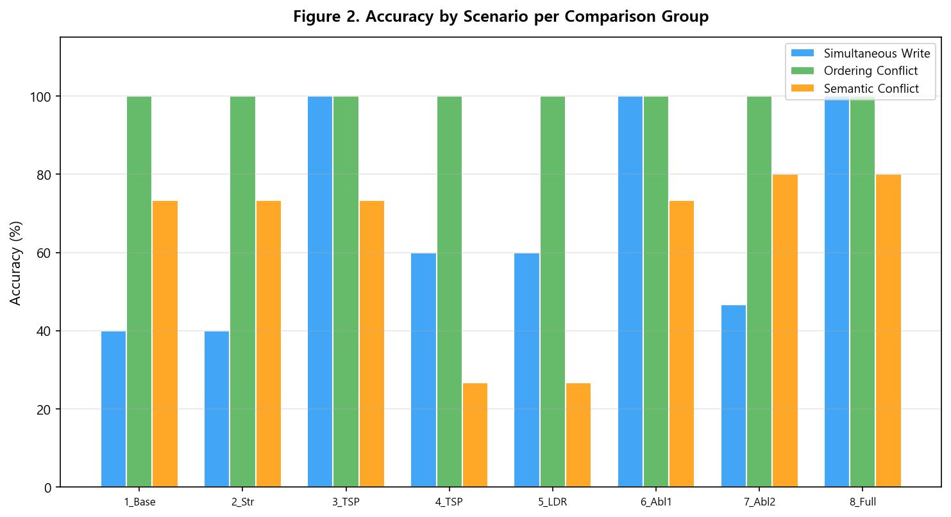
Figure 2. Accuracy Comparison by Scenario and Group

Figure 2 shows the accuracy of the 8 comparison groups for the 3 scenarios as a grouped bar chart. In the simultaneous write and ordering conflict scenarios, TimestampPriority, Ablation1, and FullProposed achieved 100%, while in semantic conflicts, only groups including Judge Agent showed high accuracy of 80.0%.

5.4 Ablation Study Analysis
Table 3 presents the results of quantitatively analyzing the individual contributions of the Judge Agent module and structural pre-filtering module through an ablation study.

Table 3. Ablation Study Δ Analysis Results
Comparison | Scenario | Δ Accuracy (%p) | Δ LLM Calls | Key Finding
Ablation1 (NoJudge) | semantic | -6.67 | 0 | Judge Agent contributes to semantic accuracy
vs FullProposed | simult_write | 0.00 | 0 | Judge Agent not needed for structural conflicts
Ablation2 (NoPreFilter) | simult_write | -53.33 | +60 | Pre-filter critical for structural accuracy
vs FullProposed | semantic | 0.00 | +60 | Unnecessary LLM calls without pre-filtering
Ablation2 (NoPreFilter) | ordering | 0.00 | +30 | LLM overhead even for trivial cases
vs FullProposed

Ablation1 (NoJudge) recorded 6.67%p lower accuracy in semantic conflicts compared to FullProposed, confirming the contribution of the Judge Agent. Ablation2 (NoPreFilter) increased LLM calls by 60 from 30 to 90 (+200% compared to FullProposed), and simultaneous write accuracy decreased by 53.3%p from 100.0% to 46.7%. This means that while the LLM-based Judge Agent is effective for natural language semantic conflicts, it has limitations for structural discrimination, and without pre-filtering, unnecessary LLM calls increase, degrading both accuracy and latency.

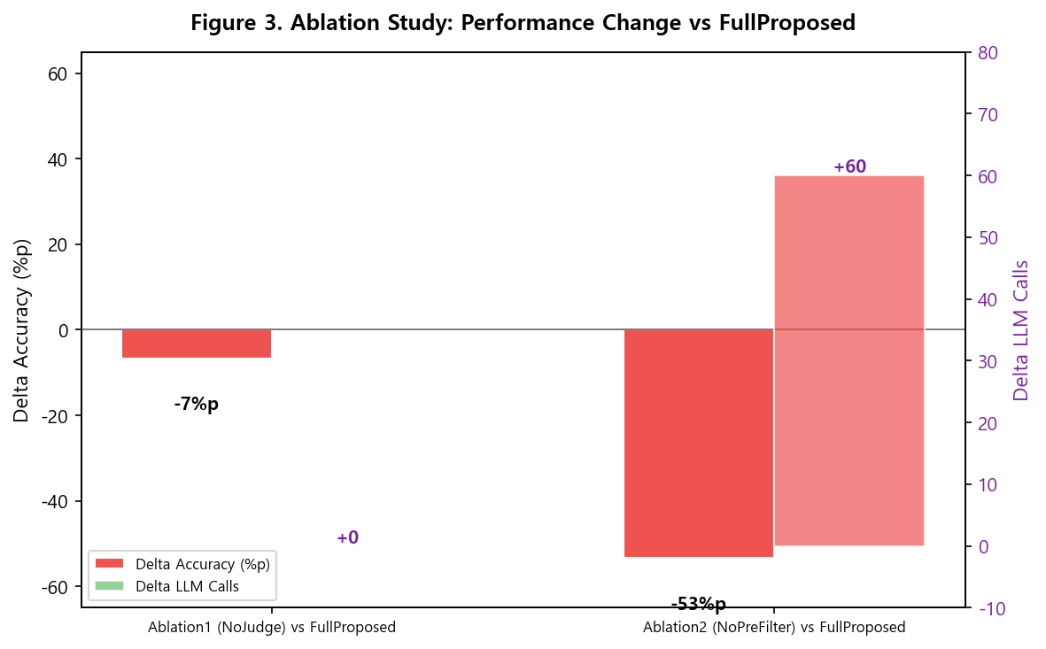
Figure 3. Performance Changes Before and After Ablation Study

Figure 3 compares the changes in key metrics of Ablation1 and Ablation2 compared to FullProposed. When the Judge Agent is removed, semantic conflict accuracy decreases, and when pre-filtering is removed, LLM calls surge and structural conflict accuracy drops significantly, visually proving that the two modules are complementary and that the proposed method represents the optimal balance point.

5.5 Latency Analysis
Table 4 presents the average latency, minimum, and maximum values for each comparison group by scenario, comprehensively showing the variability of latency.

Table 4. Detailed Latency Analysis by Scenario
Group | Simul.Write (ms) | Ordering (ms) | Semantic (ms) | Overall Avg (ms) | Min (ms) | Max (ms)
1_Baseline | 4.15 | 2.94 | 6.04 | 4.38 | 2.94 | 6.04
2_StrongOnly | 5.37 | 3.93 | 5.44 | 4.92 | 3.93 | 5.44
3_TimestampPriority | 5.31 | 2.65 | 5.11 | 4.35 | 2.65 | 5.31
4_TrustScorePriority | 6.66 | 4.37 | 5.38 | 5.47 | 4.37 | 6.66
5_LeaderMediation | 5.94 | 4.35 | 5.65 | 5.31 | 4.35 | 5.94
6_Ablation1_NoJudge | 6.62 | 3.98 | 5.74 | 5.45 | 3.98 | 6.62
7_Ablation2_NoPreFilter | 1647.83 | 1365.03 | 1444.40 | 1485.75 | 1365.03 | 1647.83
8_FullProposed | 5.69 | 3.98 | 1426.48 | 478.72 | 3.98 | 1426.48

As can be confirmed in Table 4, the latency of groups not calling LLM (1–6) is very low, within several milliseconds in all scenarios. In contrast, Ablation2 shows high latency of 1300–1700ms in all scenarios because it calls the LLM API on every execution. FullProposed maintains low latency below 10ms in structural conflict scenarios by not calling LLM, and latency increases only in semantic conflicts where LLM is called.
The proposed method (FullProposed) recorded an average latency of 478.7ms, which is 3.1 times lower than Ablation2 (1485.8ms). This means that pre-filtering effectively blocks unnecessary LLM calls, controlling not only the average latency but also its variability, supporting the practical value of pre-filtering in multi-agent systems requiring real-time collaboration.
Furthermore, due to the natural variability in LLM API response times, latency increased significantly in the semantic conflict scenarios for groups including Judge Agent (7, 8). This is attributed to the variability in DeepSeek-chat [10] API response times, and in actual service environments, variability may increase further depending on network delay and load. Therefore, the importance of pre-filtering to minimize LLM call count is a critical design consideration not only from an accuracy perspective but also from a system predictability perspective.

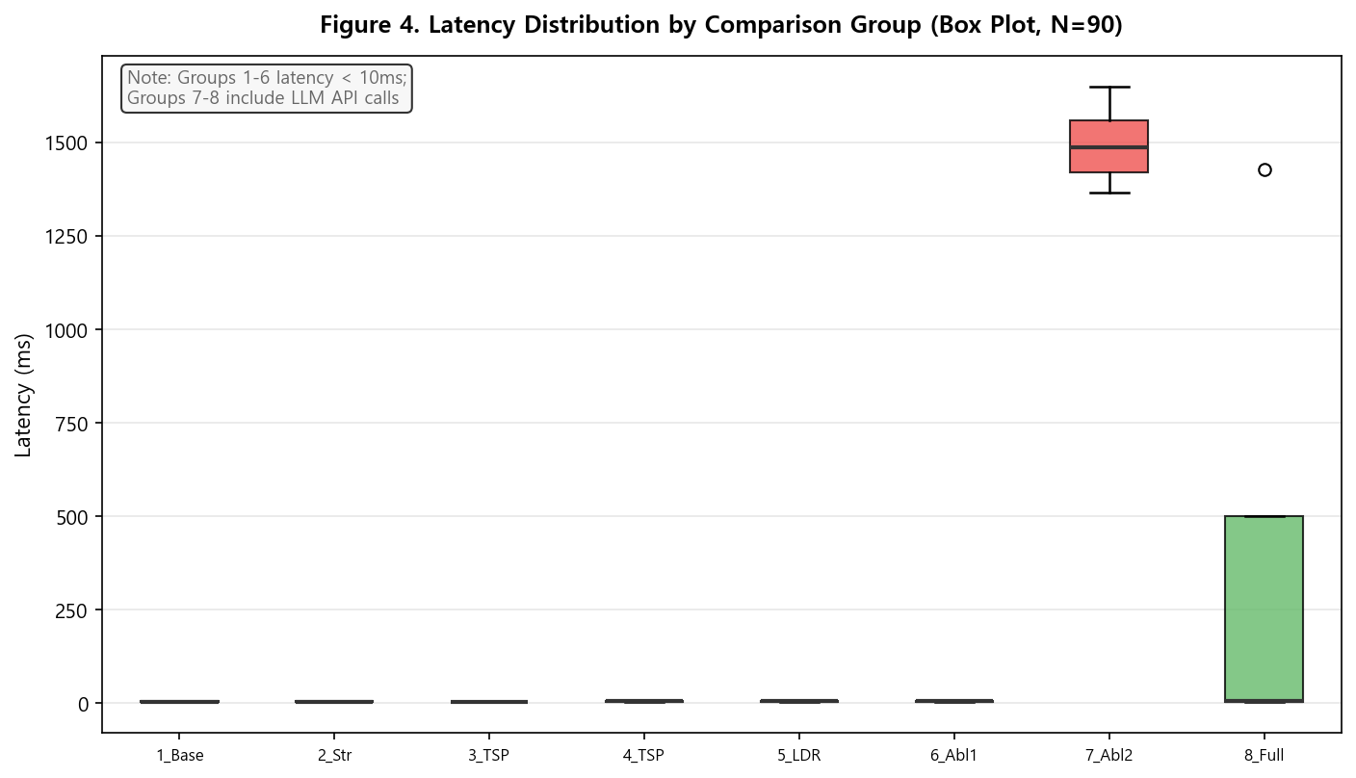
Figure 4. Latency Distribution by Group (Box Plot, N=90)

Figure 4 shows the latency distribution for all 90 experiments (3 scenarios × 30 repetitions) of the 8 comparison groups as a box plot. Groups 1–6 (low-latency group) show very stable latency within 10ms in all repetitions, while Group 7 (Ablation2) shows high and wide distribution of 1300–1700ms in all three scenarios. Group 8 (FullProposed) has a wider distribution due to LLM calls only in semantic conflict scenarios, but maintains low latency in structural conflicts, resulting in a significantly lower overall latency distribution than Group 7.

5.6 Result Interpretation and Discussion
The above experimental results can be interpreted in connection with the research hypotheses as follows.
Hypothesis H1, corresponding to RQ1 (formalization and detectability of conflict types), is supported. All groups applying the conflict detector recorded 100% memory consistency maintenance rate, while the Baseline without application recorded 0%. This empirically demonstrates that the conflict detection module is a necessary condition for ensuring memory consistency.
Hypothesis H2, corresponding to RQ2 (effectiveness of the hierarchical consistency model), is partially supported. StrongOnly showed the same accuracy (71.1%) as Baseline, confirming that conflict resolution is impossible with a single consistency level alone. In contrast, FullProposed applying hierarchical consistency achieved high accuracy of 93.3%, proving that the combination of strong consistency for working memory and eventual consistency for long-term memory is effective.
Hypothesis H3, corresponding to RQ3 (comparison among conflict resolution strategies), is supported. TimestampPriority (91.1%) showed markedly higher accuracy than TrustScorePriority (62.2%) and LeaderMediation (62.2%), meaning that the timestamp-based strategy is most effective for structural conflict resolution. Trust-score-priority and leader mediation strategies dropped to 26.7% in semantic conflicts, confirming that a single rule-based approach alone cannot adequately resolve semantic conflicts.
Hypothesis H4, corresponding to RQ4 (effectiveness of Judge Agent's semantic conflict detection), is supported. Groups including Judge Agent recorded 80.0% accuracy in semantic conflicts, showing higher performance than groups without Judge Agent. This proves that LLM-based semantic judgment is effective for resolving semantic conflicts that cannot be detected by structural methods.
Hypothesis H5, corresponding to RQ5 (confirmation of per-module contributions through ablation study), is supported. When the Judge Agent was removed, semantic conflict accuracy decreased, and when pre-filtering was removed, LLM calls increased 3-fold and structural conflict accuracy decreased by 53.3%p, quantitatively proving the complementary contributions of both modules.
Regarding the interpretation of results that differ from expectations, the following two points are discussed separately.
Interpretation of StrongOnly (Group 2)'s low performance: StrongOnly recorded the same comprehensive accuracy (71.1%) and memory consistency maintenance rate (0%) as Baseline. This is a result that contradicts the intuitive expectation that 'applying strong consistency would automatically resolve conflicts,' requiring separate interpretation. In this study, strong consistency was implemented as a lock-based serialization mechanism whose role is to guarantee the order of concurrent read/write operations. That is, strong consistency ensures that agents always read the latest value, but does not have the ability to judge or resolve conflicts that have already occurred. Therefore, when a conflict occurs, the later write simply overwrites the earlier write, resulting in behavior identical to last-write-wins.
Reason for Ablation2's low simultaneous write conflict accuracy: The reason Ablation2's simultaneous write conflict accuracy is low is that the Judge Agent cannot properly interpret the meaning of structural information such as version strings, meaning that while the LLM-based Judge is effective for natural language semantic conflicts, it has limitations for structural discrimination.
In summary, the proposed method (FullProposed) achieved an average accuracy of 93.3% across all scenarios with a 100% memory consistency maintenance rate, demonstrating clear improvement over existing simple last-write-wins methods or single mediation strategy methods. The core contributions of this study are: (1) formal definition of multi-agent shared memory conflict types; (2) integrated design of the hierarchical consistency model with structural pre-filtering and Judge Agent; and (3) quantitative verification of each module's individual contributions through 8 comparison groups and ablation studies.
From a practical perspective, shared memory in multi-agent systems must include at minimum conflict detection and version management mechanisms, and timestamp-based structural filtering is simple to implement while providing high accuracy for structural conflict resolution. The LLM-based Judge Agent is effective for semantic conflicts, but considering the costs of latency increase and variability, integration with pre-filtering is essential. However, since these results were derived under limited conditions of 3 agents, a controlled experimental environment, a single DeepSeek-chat model, and 15 semantic conflict pairs, caution is required in generalizing to environments with more agents, diverse LLM models, and distributed settings.
In conclusion, these experimental results preliminarily prove that the hierarchical consistency model and Judge Agent-based integrated conflict resolution mechanism are practical and effective design directions in multi-agent shared memory environments, and hold significance as foundational research that can contribute to improving the reliability of future LLM-based multi-agent systems.

Chapter 6 Conclusion and Implications
Synthesizing the above results, the proposed method of this study showed meaningful potential in multi-agent shared memory environments, and this chapter presents conclusions and implications based on these findings.

6.1 Research Summary
This study aimed to design a hierarchical consistency model applying strong consistency to working memory and eventual consistency to long-term memory, and to propose an integrated conflict resolution mechanism combining timestamp-priority, trust-score-priority, leader-agent mediation, and LLM-based Judge Agent, to resolve conflicts arising when multiple agents simultaneously access and update the same memory entries in multi-agent shared memory systems. To this end, three conflict types—visibility conflicts, ordering conflicts, and semantic conflicts—were formally defined, and a Python-based prototype and SQLite shared memory storage were implemented to verify the effectiveness through experiments with 8 comparison groups.
As a result of the experiment, the proposed method (FullProposed) recorded an average conflict resolution accuracy of 93.3% across all scenarios, showing a 22.2%p performance improvement over the Baseline (71.1%), and all comparison groups applying conflict detection and resolution mechanisms achieved 100% memory consistency maintenance rate. In the semantic conflict scenario, groups including Judge Agent recorded 80.0% accuracy, proving the effectiveness of LLM-based semantic judgment by showing higher performance than groups without Judge Agent. Furthermore, through ablation studies, it was quantitatively verified that structural pre-filtering and Judge Agent have complementary contributions.

These results suggest that in multi-agent shared memory environments, simple last-write-wins methods or single mediation strategies alone cannot effectively cope with various types of conflicts, and that hierarchical consistency models and structural-semantic integrated conflict resolution mechanisms are practical and effective design directions. In particular, this study integrates memory structure, consistency level, conflict mediation strategy, and semantic adjustment into a single framework, and quantitatively verifies the individual contributions of each component through 8 comparison groups and ablation studies, providing implementable guidelines for improving the reliability of multi-agent shared memory systems.

6.2 Research Implications

6.2.1 Academic Implications
First, this study formally defines conflicts occurring in multi-agent shared memory environments into three types—visibility conflicts, ordering conflicts, and semantic conflicts—and specifies detection conditions and resolution criteria for each type. Unlike existing studies that only conceptually mention conflict problems, this study defines the three conflict types at the operational level and verifies the occurrence conditions and resolution possibilities for each type through experiments, thereby more rigorously establishing the conceptual foundation for multi-agent memory conflict research.
Second, this study empirically verifies the effectiveness of a hierarchical approach for applying traditional consistency models from the distributed systems field to LLM-based multi-agent memory environments. While uniformly applying a single consistency level to the entire memory showed no significant improvement over Baseline, the hierarchical design applying differentiated levels to working memory and long-term memory was experimentally shown to secure the balance between accuracy and efficiency, adding a new design dimension of memory layer differentiation to consistency model research.
Third, this study presents a systematic experimental framework that enables comparative evaluation of structural conflict resolution strategies and semantic conflict resolution strategies under the same experimental conditions. In particular, by demonstrating that individual contributions can be quantitatively separated and measured through the design of 8 comparison groups including ablation studies, it provides an experimental design model that can be referenced for the evaluation methodology of future similar multi-agent memory research.

6.2.2 Practical Implications
First, when building actual multi-agent systems, shared memory must necessarily include at minimum conflict detection and version management mechanisms. The result that Baseline's memory consistency maintenance rate was 0% means that shared memory without conflict management functions cannot practically maintain a consistent state in multi-agent collaboration environments.
Second, timestamp-based structural pre-filtering is relatively simple to implement while providing high resolution accuracy for structural conflicts, and can be considered as a lightweight conflict resolution technique that can be practically introduced first.
Third, the LLM-based Judge Agent is effective for resolving semantic conflicts, but entails practical costs of increased latency and variability due to API calls. Therefore, in practice, a two-stage architecture that performs primary screening through structural filtering and selectively calls the Judge Agent only when natural language semantic conflicts are suspected is recommended as a cost-effective design strategy.
Fourth, the hierarchical consistency design of this study holds practical implications that can be directly referenced in the shared memory module design of recently notable multi-agent frameworks such as AutoGPT [13], MetaGPT [14], and CrewAI [15].

6.3 Limitations of the Study
This study has the following limitations, which impose certain constraints on the interpretation and generalization of the research results.
First, the experiments of this study were conducted in a limited scale of 3 agents (Planner, Executor, Reviewer) and a controlled experimental environment. As the number of agents increases, concurrent access frequency and conflict occurrence patterns may change, and particularly leader-agent-based mediation strategies may change in performance characteristics depending on agent scale. Therefore, caution is required in generalizing the accuracy and latency figures confirmed in this study to actual multi-agent collaboration environments with more agents.
Second, semantic conflict scenarios were evaluated based on 15 predefined contradictory pairs, and ground truth labels were set according to the researcher's sole judgment. The Judge Agent's 80.0% accuracy should be understood as performance within these limited scenarios, and additional verification is needed for generalization to more diverse and realistic semantic conflict situations.
Third, since this study used only a single LLM model, DeepSeek-chat [10], as the Judge Agent, the Judge Agent's performance may depend on the characteristics of the specific model used. Using different LLM models as Judge Agents may result in different semantic conflict detection accuracy and latency, and the natural variability in LLM API response times affected the latency distribution of experimental results.
Fourth, the prototype designed in this study used a SQLite-based single-machine shared memory structure, and performance in distributed environments separated by networks was not verified. If actual multi-agent systems operate in distributed network environments, additional variables such as network delay, message loss, node failures, and network partitions may affect the operation of the hierarchical consistency model and conflict resolution mechanism.

6.4 Future Research Directions
Based on the above limitations, future research needs to be expanded in the following directions.
1. Gradually expand the number of agents to 10, 20, 50, etc., diversify the types of roles, and systematically analyze the impact of agent scale and role diversity on the performance of the conflict resolution mechanism.
2. Build more diverse and realistic semantic conflict datasets, introduce a ground truth labeling system with multiple evaluators, and conduct comparative experiments with various LLM models such as GPT-4, Claude, and Gemini as Judge Agents.
3. Extend the prototype of this study to a distributed environment to verify the impact of network delay, message loss, node failures, and network partitions on the hierarchical consistency model and conflict resolution mechanism, and analyze the trade-off characteristics between consistency, availability, and partition tolerance from the perspective of the CAP theorem [6].
4. Integrate the proposed hierarchical consistency model and conflict resolution mechanism into the shared memory modules of actual multi-agent frameworks such as AutoGPT [13], MetaGPT [14], and CrewAI [15], and evaluate empirical effectiveness in specific application tasks such as code generation, data analysis, and document writing.
5. Research a reinforcement learning-based adaptive conflict resolution mechanism that determines Judge Agent invocation and strategy selection in real time by comprehensively considering conflict type prior probabilities, agent trust score trends, and system load conditions.

References
[1] Gu, Y.; et al. (2024). Memory in Multi-Agent Systems: Shared Memory and Distributed Memory Paradigms. arXiv preprint.
[2] Mao, Y.; et al. (2024). AMA: Adaptive Memory Management for Multi-Agent Systems with Role-Based Agents. Proceedings of NeurIPS.
[3] Herlihy, M. P.; & Wing, J. M. (1990). Linearizability: A Correctness Condition for Concurrent Objects. ACM Transactions on Programming Languages and Systems, 12(3), 463–492. https://doi.org/10.1145/78969.78972
[4] Vogels, W. (2009). Eventually Consistent. Communications of the ACM, 52(1), 40–44. https://doi.org/10.1145/1435417.1435432
[5] Ahamad, M.; Neiger, G.; Burns, J. E.; Kohli, P.; & Hutto, P. W. (1995). Causal Memory: Definitions, Implementation, and Programming. Distributed Computing, 9(1), 37–49. https://doi.org/10.1007/BF01784241
[6] Brewer, E. A. (2000). Towards Robust Distributed Systems. Proceedings of the ACM Symposium on Principles of Distributed Computing (PODC). http://www.podc.org/podc2000/brewer.html
[7] Lamport, L. (1978). Time, Clocks, and the Ordering of Events in a Distributed System. Communications of the ACM, 21(7), 558–565. https://doi.org/10.1145/359545.359563
[8] Garcia-Molina, H.; & Salem, K. (1987). Sagas. Proceedings of the ACM SIGMOD International Conference on Management of Data, 249–259. https://doi.org/10.1145/38713.38742
[9] Terry, D. B.; Theimer, M. M.; Petersen, K.; Demers, A. J.; Spreitzer, M. J.; & Hauser, C. H. (1995). Managing Update Conflicts in Bayou, a Weakly Connected Replicated Storage System. Proceedings of the ACM Symposium on Operating Systems Principles (SOSP), 172–183. https://doi.org/10.1145/224056.224070
[10] DeepSeek. (2024). DeepSeek API Documentation. https://api.deepseek.com
[11] OpenAI. (2024). OpenAI Python SDK Documentation. https://github.com/openai/openai-python
[12] SQLite. (2024). Write-Ahead Logging. https://www.sqlite.org/wal.html
[13] AutoGPT Team. (2024). AutoGPT: Autonomous AI Agent Framework. https://github.com/Significant-Gravitas/AutoGPT
[14] MetaGPT Team. (2024). MetaGPT: Multi-Agent Meta Programming Framework. https://github.com/geekan/MetaGPT
[15] CrewAI Team. (2024). CrewAI: Framework for Orchestrating Role-Playing AI Agents. https://github.com/crewAIInc/crewAI

국문 초록
멀티 에이전트 공유 메모리 시스템에서의
계층형 일관성 모델 및
충돌 해소 메커니즘 설계
위바오치
Major of Computer Science and Technology
Graduate School of Youngsan University
담당교수 : 백 건 효
멀티 에이전트 시스템에서 공유 메모리는 에이전트 간 상태 동기화와 지식 공유를 위한 핵심 구성 요소이다. 그러나 여러 에이전트가 동시에 동일한 메모리 항목에 접근하고 갱신할 때 가시성 충돌, 순서성 충돌, 의미적 충돌이 발생할 수 있으며, 이를 적절히 관리하지 못하면 메모리 상태의 불일치가 누적되어 시스템의 신뢰성을 크게 훼손할 수 있다. 본 연구는 이러한 문제를 해결하기 위해 작업 메모리에는 강한 일관성을, 장기 메모리에는 최종 일관성을 적용하는 계층형 일관성 모델을 제안하고, 타임스탬프 우선·신뢰도 우선·리더 에이전트 중재·LLM 기반 Judge Agent를 통합한 충돌 해소 메커니즘을 설계하였다. 가시성 충돌, 순서성 충돌, 의미적 충돌의 세 가지 충돌 유형을 형식적으로 정의하고, Python 기반 프로토타입과 SQLite 공유 메모리 저장소를 구현하여 Planner·Executor·Reviewer의 세 역할 에이전트가 참여하는 실험 환경에서 8개 비교군을 대상으로 3종의 충돌 시나리오를 각 30회 반복 수행하는 실험을 실행하였다. 실험 결과, 제안 방식(FullProposed)은 전체 시나리오 평균 93.3%의 충돌 해결 정확도를 기록하여 Baseline(71.1%) 대비 22.2%p 향상된 성능을 보였으며, 충돌 탐지 및 해소 메커니즘을 적용한 모든 비교군에서 메모리 일관성 유지율 100%를 달성하였다. 의미적 충돌 시나리오에서는 Judge Agent를 포함한 그룹이 80.0%의 정확도를 기록하여 LLM 기반 의미 판단의 유효성을 입증하였으며, 소거 실험(Ablation Study)을 통해 구조적 사전 필터링과 Judge Agent의 상호 보완적 통합이 정확도와 효율성의 균형을 확보하는 핵심 설계 요소임을 확인하였다.

키워드: 멀티 에이전트 시스템, 공유 메모리, 계층형 일관성 모델, 충돌 해소 메커니즘, Judge Agent, LLM

ABSTRACT
Design of a Hierarchical Consistency Model
and Conflict Resolution Mechanism
in Multi-Agent Shared Memory Systems
YU BAOQI
Major of Computer Science and Technology
Graduate School of Youngsan University
Advisor: 백 건 효
In multi-agent systems, shared memory serves as a core component for state synchronization and knowledge sharing among agents. However, when multiple agents concurrently access and update the same memory entries, visibility conflicts, ordering conflicts, and semantic conflicts can arise. If not properly managed, accumulated memory inconsistencies can severely undermine system reliability. To address these challenges, this study proposes a hierarchical consistency model that applies strong consistency to working memory and eventual consistency to long-term memory, and designs an integrated conflict resolution mechanism combining timestamp priority, trust score priority, leader agent mediation, and an LLM-based Judge Agent. Three conflict types—visibility, ordering, and semantic—are formally defined. A Python-based prototype with SQLite shared memory storage was implemented, and experiments were conducted with three role-based agents (Planner, Executor, Reviewer) across 8 comparison groups under 3 conflict scenarios with 30 iterations each, totaling 720 experimental runs. Experimental results demonstrate that the proposed approach (FullProposed) achieved an average conflict resolution accuracy of 93.3% across all scenarios, representing a 22.2%p improvement over Baseline (71.1%). All groups equipped with conflict detection and resolution mechanisms achieved 100% memory consistency rates. In semantic conflict scenarios, groups incorporating the Judge Agent achieved 80.0% accuracy, validating the effectiveness of LLM-based semantic judgment. Ablation studies confirmed that the complementary integration of structural pre-filtering and the Judge Agent is a key design factor for balancing accuracy and efficiency. The proposed approach recorded an average latency of 478.7ms, approximately 3.1× lower than the configuration without pre-filtering (1485.8ms), demonstrating that pre-filtering effectively controls both the mean and variance of latency while maintaining high accuracy.

Keywords: Multi-Agent System, Shared Memory, Hierarchical Consistency Model, Conflict Resolution Mechanism, Judge Agent, LLM

APPENDIX
Experiment code: https://github.com/ybq9430/multi-agent-shared-memory-experiment

